# Project 31: Alpha Car Hire - Car Rental Portal Management System

# Introduction

Transportation is very common problem in Australia if u do not have any personal vehicle. On different occasions, the necessity of a vehicle required. Therefore, this project is intended to be used by Alpha Automobile Hire Company, which is one of the largest independent car rental companies in Australia, if it is possible to construct the system that will assist renter and transport provider to solve the transportation problem. This company offers a wide range and great quality of vehicles in low cost (Vijaykumar Mohite, 2022). Nowadays world is small because of internet. Everything is one click away from us. If we want to shop we can do through online so why not renting a car through online portal? SO in order to solve the car hiring problem this system is developed. Customers can check availability of the automobiles, can register, can read their profiles, and rent a car using this online system. Peoples have faced many difficulties while moving large luggage or needing more leg space, etc. To solve this problem we have created alpha car hire portal through which we can hire the car according to our choice and our requirements. This system consists of many features such as login, Car gallery, Customer information management, customer credentials will be safe, car review management, payment management module, etc. Administrators, moderators, users, and car owners will all use login to enter the system and carry out their respective user-specific tasks and actions. This system is developed to be able to use today’s technology for renting cars to the global world instead limiting theirs services to their local domain (InstantEduHelp, 2022).

## Background of project

Car Rental Portal Management System is a web based system for an Alpha Car Hire company which rents out cars to the customer. This system is developed to help the company which make their services available to the customer via internet and also keep records of every customers, vehicle, ride history, etc. This business provides short-term car rentals for a few days or a week. To expand their business and make popular this business is transformed in web based online portal from which everyone can have access to rent or hire the car. This will help customer and company in many ways. This system makes the renting of cars very easy which will saves time and labour. Customer can choose the cars they want according to their need and requirement. The admin of the system register the staff and driver or car owners but client can be register by themselves. The customer can use the internet to log into the system after registering. The customer can then select the car and make their selection based on their needs. Then, other processing will be done and notification will be sent to the car owners and admin (Firsthand, 2022).

## Purpose of Project

Getting the car in rent is very hectic job which requires lots of time. When people don’t have access to their personal cars or don’t own one then renting the cars make their life easier. So, the main purpose of this project is to create the system which will help the customer to rent or pick the car online with one click away. This project is also required by Alpha car Hire Company which is going according to trend which means going online. This system will make peoples life easier because renting a car through online will save lot more of time. This system maintains detailed information of both the vehicle and the consumers, including the length of time and type of vehicle rented (Docket, 2022).

## 9. Sequence Diagram

Interaction diagrams called sequence diagrams show the steps that an operation must take. They depict how items interact within the framework of a cooperation. By utilizing the vertical axis of the diagram to represent time and the messages that are transmitted and when, sequence diagrams, which have a time emphasis, may graphically depict the order of an interaction (Geeksforgeeks, 2022).

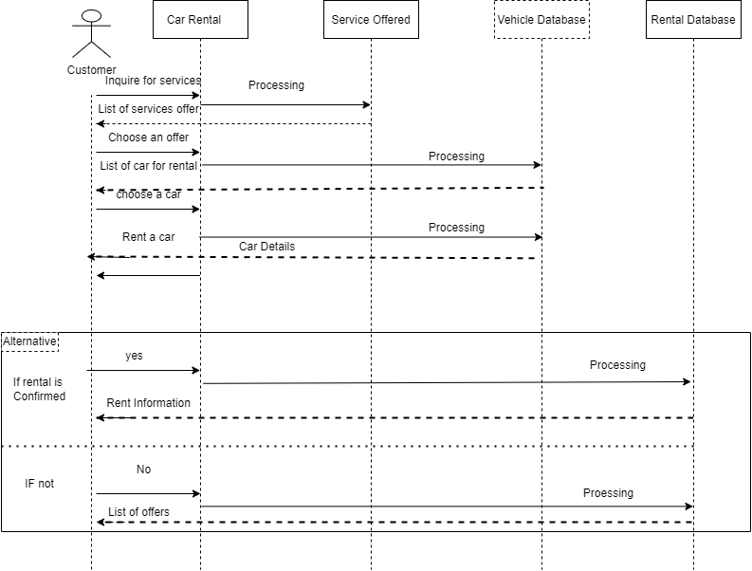

Figure 2: Sequence Diagram

# References

Docket. (2022, May 27). *Project Purpose Statement*. Retrieved from Docket: https://www.dockethq.com/resources/3-project-purpose-statement-examples-for-clearer-scope/

Firsthand. (2022, August 18). *Project Management*. Retrieved from Firsthand: https://firsthand.co/industries/project-management/background

Geeksforgeeks. (2022, May 06). *Unified Modeling Language (UML) Sequence Diagrams*. Retrieved from Geeksforgeeks: https://www.geeksforgeeks.org/unified-modeling-language-uml-sequence-diagrams/

InstantEduHelp. (2022, August 17). *Car Rental Management System Project for Final Year*. Retrieved from InstantEduHelp: https://instanteduhelp.com/car-rental-management-system/

Vijaykumar Mohite, P. M. (2022, May 16). *Online Car Rental system*. Retrieved from ijraset: https://www.ijraset.com/research-paper/online-car-rental-system-using-web-technology